function getCollectionIndexes(col){

const indexStats = (() => {

const dbVersion = parseFloat(db.version());

if (dbVersion >= 3.2) {

try{

return db.getCollection(col).aggregate([{ $indexStats: {} }]).toArray()

}catch(err){

console.error(err)

return [];

}

}

})();

const indexSizes=db.getCollection(col).stats().indexSizes;

const indexes=db.getCollection(col).getIndexes();

return indexes.map(it=>{

const usageStats=(()=>{

const stats=(indexStats || []).filter(stat=>stat.name===it.name);

if (_.isEmpty(stats)) return {"usage stats": "not available"};

const formatAccesses=(it)=>`${it.ops} since ${it.since.toLocaleString()}`

if (stats.length>1){

return {

"usage stats":stats.reduce((acc, cur, i)=> {

acc[i]={

host:cur.host,

accesses:formatAccesses(cur.accesses)

}

return acc;

}, {})

}

}else{

return {

...stats[0],

accesses: formatAccesses(stats[0].accesses),

}

}

})();

const size=indexSizes[it.name];

const type=(_.find(_.values(it.key), v=>_.isString(v)) || "regular").toUpperCase();

const info={

...it,

size,

type,

...usageStats,

}

const commonFields=["name","key","type","size", "ns","accesses","usage stats"];

if (!info.ns){

info.ns=db.getName()+"."+col;

}

return _.omitBy({

..._.pick(info,commonFields),

...{properties: _.omit(info, [...commonFields,"v","host"])},

..._.pick(info,"v","host")

},_.isEmpty)

})

}

getCollectionIndexes("envio");

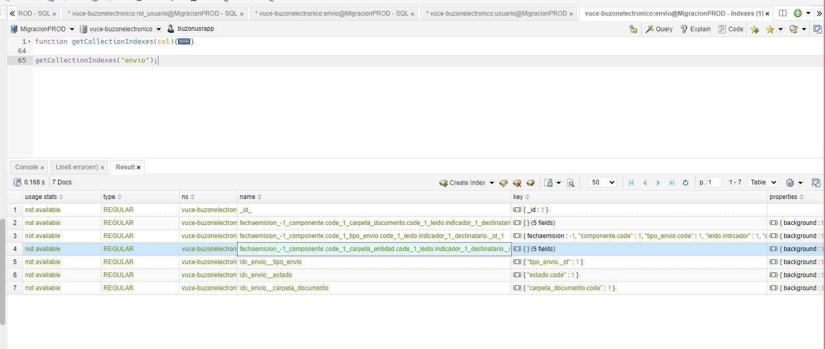

db.usuario.find({

_id: ObjectId("63445bff14b6d9126a92a2bc")

})

441740

db.usuario.find({

usuario_id: 441740

})

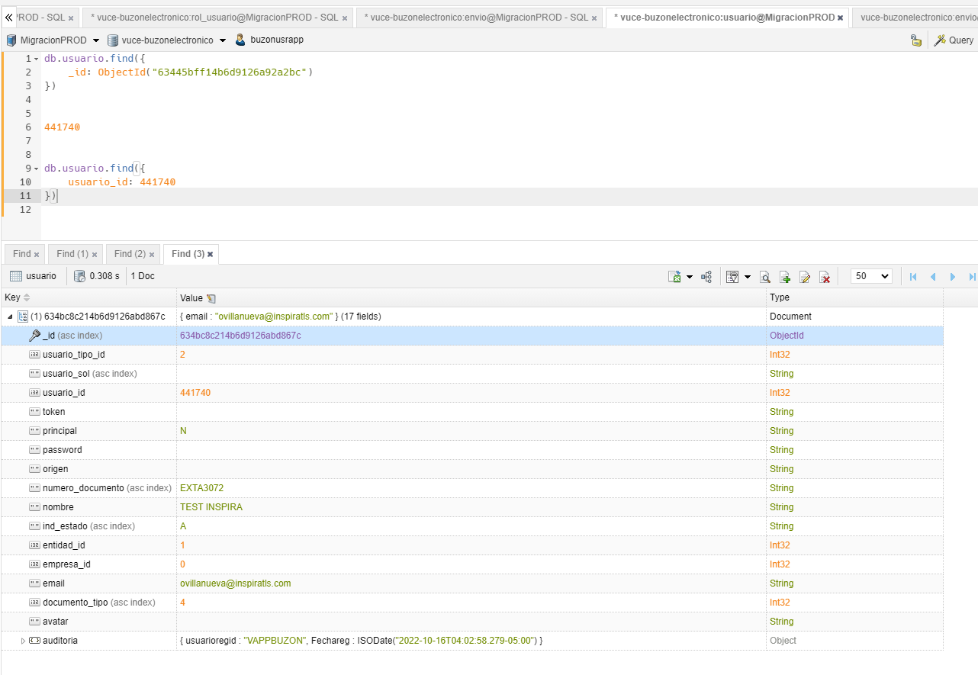

db.envio.find({

"fechaemision" : {

$gte: ISODate("2024-12-01T00:00:00.000Z"),

$lte: ISODate("2024-12-07T23:59:59.999Z")

},

"componente.code": "MR",

"tipo_envio.code": "MS",

"leido.indicador": false,

"auditoria.usuarioregid": { $in: [441740]},

})

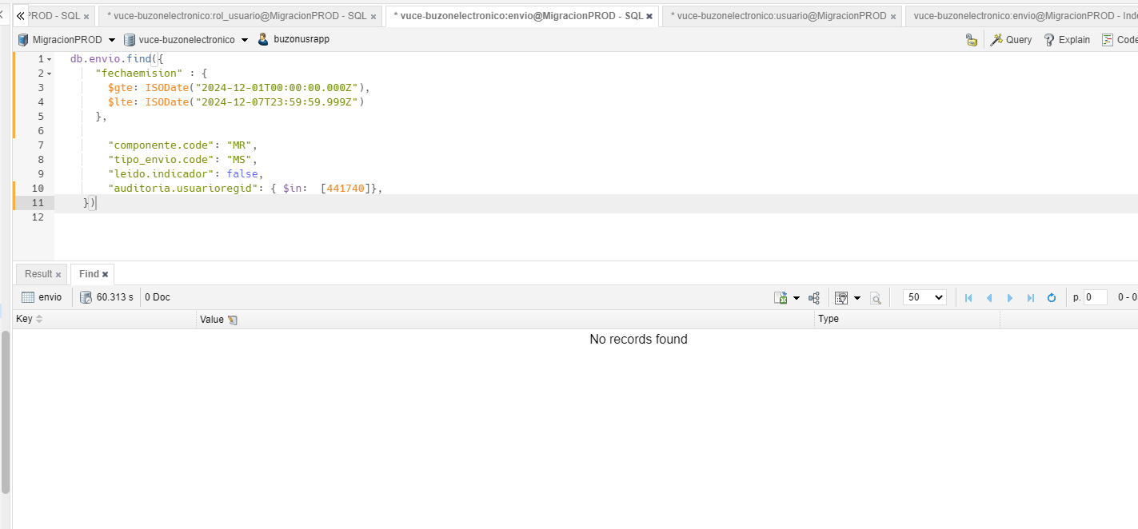

db.rol_usuario.find({

"rol.nombre" : "BUZON.ADMINISTRADO"

,"componente": "MR"

,

})

.limit(10)

//para obtener propietario.code (codigo/ id del usuario)

db.rol_usuario.find({

"propietario.code" : "634bc8c214b6d9126abd867c"

// ,"componente": "MR"

,

})

.limit(10)

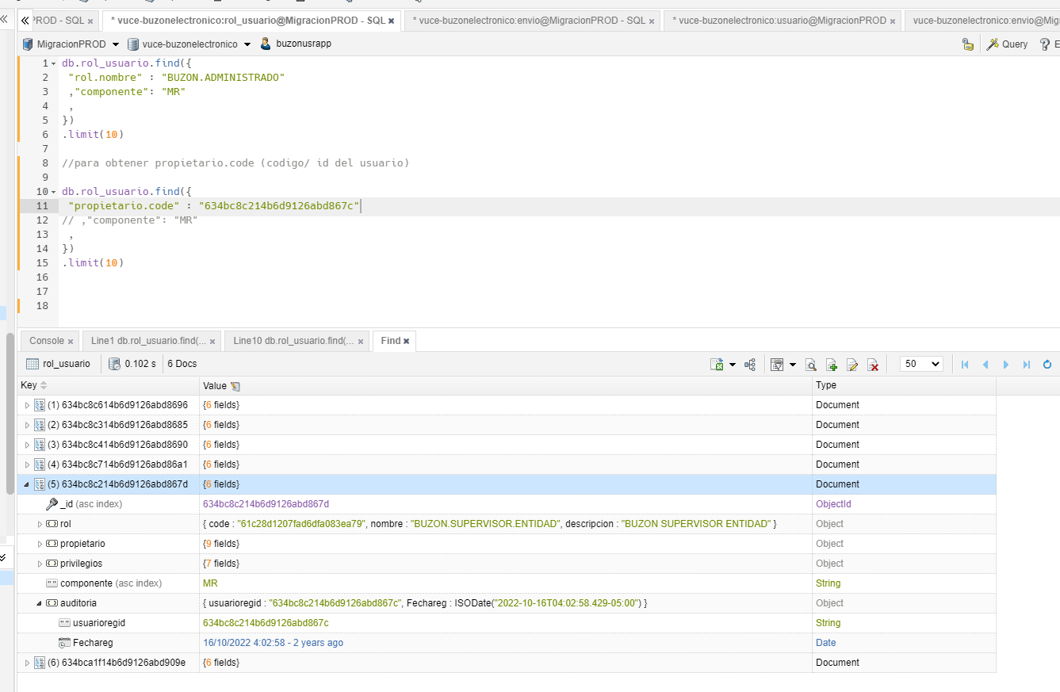

db.rol.find({

"nombre" : "BUZON.ADMINISTRADO"

})

//para Obtener el _id

